from spectralcluster import SpectralClusterer

clusterer = SpectralClusterer(

min_clusters=2,

max_clusters=100,

p_percentile=0.95,

gaussian_blur_sigma=1)

labels = clusterer.predict(X)

where X is a NumPy array of shape (n_samples, n_features) and the returned labels is a NumPy array of shape (n_samples, ).

from sklearn.cluster import SpectralClustering

from sklearn.datasets.samples_generator import make_blobs

import matplotlib.pyplot as plt

from numpy import random

random.seed(1)

x, _ = make_blobs(n_samples=400, centers=4, cluster_std=1.5)

plt.scatter(x[:,0], x[:,1])

plt.show()

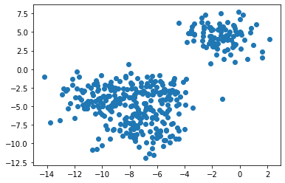

Clustering with the spectral clustering and visualizing the data

sc=SpectralClustering(n_clusters=4).fit(x)

SpectralClustering(affinity='rbf', assign_labels='kmeans', coef0=1, degree=3,

eigen_solver=None, eigen_tol=0.0, gamma=1.0,

kernel_params=None, n_clusters=4, n_components=None,

n_init=10, n_jobs=None, n_neighbors=10, random_state=None)

labels = sc.labels_

plt.scatter(x[:,0], x[:,1], c=labels)

plt.show()

print(sc)

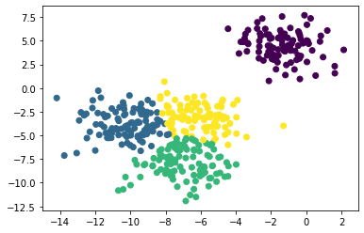

Let’s try changing the number of clusters.

f = plt.figure()

f.add_subplot(2, 2, 1)

for i in range(2, 6):

sc = SpectralClustering(n_clusters=i).fit(x)

f.add_subplot(2, 2, i-1)

plt.scatter(x[:,0], x[:,1], s=5, c=sc.labels_, label="n_cluster-"+str(i))

plt.legend()

plt.show()

